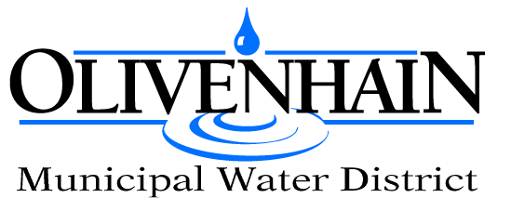

BOARD DIRECTOR - DIVISION 1 APPLICATION
You must reside within the boundaries of OMWD Division 1. If appointed, you must take an oath of office to fulfill the term of Division 1.

Full Name: ________________________________________________________

Home Address: ____________________________________________________

City: ___________________________ State: _________ Zip: _______________

Cell phone: _____________________ Home phone: ______________________

Email address: ____________________________________________________

Attach a current resume with a letter of interest. You may also attach other additional information that you would like to include with this application packet.

Please answer the following supplemental questions:

- Discuss your experience in legislative advocacy, public sector, and/or community service.

- Describe your experience related to the water, wastewater, hydroelectric, or parks and recreation industry.

- Explain your past interactions with Olivenhain Municipal Water District.

- What qualifications should we consider that would help us make our board appointment decision?
- Please set forth your availability for board meetings, committee assignments, and other regional and statewide functions representing OMWD.

Signature: __________________________________ Date: _____________

Application materials should be submitted by 5:00 p.m. on Monday, 03/03/2025, to: OMWD General Manager, 1966 Olivenhain Rd. Encinitas, CA 92024 or via email to skaufmann@olivenhain.com. Public interviews will be conducted by the Board in Open Session, at the OMWD Board Meeting on Wednesday, 03/19/2025 at 4:00 p.m.

